Warning – MyKey Active – CGEA 1.3

Functional Description

The purpose of the MyKey Active Warning is to provide the MyKey Restricter User with a visual warning at vehicle start to serve as a reminder that the MyKey system is active.

The MyKey Active Warning function correlates the Current_Ign_Key_Dev_type signal and the operational mode to display the appropiate warning in the message center.

Interfaces

Interface Context Diagram (I/O Block Diagram)
Figure 1 Warning – MyKey Active Context Diagram

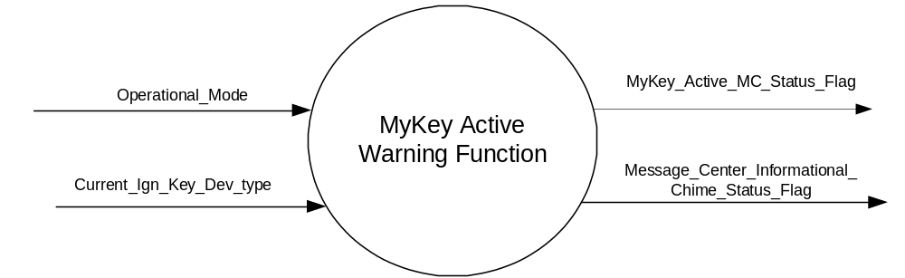

Inputs
      - INTERNAL:
- Operational_Mode
- Current_Ign_Key_Dev_Type: Used to indicate the type of key currently in use in the vehicle. See MyKey Control Function SPSS for further definition.

Outputs
MyKey_Active_MC_Status_Flag that is used to control the Warning displayed in the message center.
Message_Center_Informational_Chime_Status_Flag

Function/Performance

Operational Modes

Mode | Differentiating Vehicle Conditions
Sleep Mode | OFF
Limited Mode | OFF
Normal Mode | MyKey Active Warning Text Message OFF/ON
Crank Mode | OFF

Voltage Levels

Refer to the Cluster Features Table located in the Operational Modes and Voltage Range Strategies Section of this SPSS

Human-Machine Interface

Visual

Indicator Graphics / Display Format
Message Center Text Warning Message as defined in section 1.3.5.7 of this document.

1.3.3.1.2 Indicator Color Coordinates

Reference section COLOR & ILLUMINATION REQUIREMENTS (GRAPHICS).

Audio

Message_Center_Informational_Chime_Status_Flag is associated with this warning (with W860).

Switch Control Logic

None.

System Accuracy

Within 100 msec of receiving a message that results in a change of state the cluster will update the output flag to the proper state.

Operation: Performance and Functional

Subsystem Algorithm Flowchart / State Diagram

- State Matrix for Warning – MyKey Active

Operational_Mode | Current_Ign_Key_Dev_Type | MyKey_Active_ MC_Status_Flag | Active Chime_Status_Flag
Normal | Key_In_Ign_My_Key | ACTIVE | Message_Center_Informational_Chime_Status_Flag
All Other Cases |  | INACTIVE | None

Operation Description (supports algorithm flowchart /state diagram)

- When MyKey_Active_MC_Status_Flag = ACTIVE, Warning ID W860 will be ACTIVE.
- For definition of how the Message Center arbitrates and displays Active warnings, see the Warning / Alert Display Logic Diagram, located in the Message Center – X Display with W Button Interface section of this SPSS (where X and W are appropriate values in this document).

Function Safety Classification (EMC)

Class B

Memory Storage

Parameter Name | Description | Value at  Battery Connect | Value at  Module Wake-up
MyKey_Active_MC_Status_Flag | Used to control the state of the warning to the Message Center arbitrator | INACTIVE (0x0) | INACTIVE (0x0)
Current_Ign_Key_Dev_Type | Used to indicate the type of key currently in use in the vehicle. See MyKey Control Function SPSS for definition. | Unknown (0x0E) | Unknown (0x0E)
Operational_Mode | 4 state indicator for cluster operational mode | Limited | Limited or Normal or Crank
Message_Center_Informational_  Chime_Status_Flag | Used to control the state of the chime to the Chime Arbitrator | Inactive | Inactive

Prove Out

No.

Reconfigurable Telltale

No.

Message Center Msg

Warning Message ID W860, as defined in the Text Message List section of this SPSS.

Error Handling

Not Applicable

Diagnostics

Self Test

None

Engineering Test Mode

Not Applicable

Part II Performance

Not Applicable

Reference Specification

Not Applicable

Revision History

SPSS Module Revision History

Revision Level | Name | Change Description | Date
1.0 | S. Watkins | No updated for CGEA 1.3. Same STSS as CGEA 1.2/1.2 version 1.0 | 12/2/2010
1.1 | Ilopezla | This update adds the Chime_Status_Flag Associated with this warning (all changes are highlighted in blue).  Section 1.2.1 Figured 1 Added  Message_Center_Informational_Chime_Status_Flag  Section 1.2.3 Added Message_Center_Informational_Chime_Status_Flag  Section 1.3.3.2  Replaced “Warning Chime is associated with this Warning.” with  “Message_Center_Informational_Chime_Status_Flag is associated with this warning (with W860).”to indicate the associated Chime_Status_Flag as per Global_Msg_List_ver32_Released_6_24_2015  Table 1.0 Added Active Chime_Status_Flag column.  Section 1.3.5.4 Added Message_Center_Informational_Chime_Status_Flag  to memory storage | 12/18/2015

